A P300 Brain Computer Interface Based Virtual Simulation

**What is Brain-Computer Interface (BCI)?**

BCI is a new brain-based control machine approach detected by electroencephalography (EEG). This technique is risk-free because it relies on the use of non-invasive dry electrodes that detect only the brain signals from the scalp surface. BCI is the user-computer's most intuitive interface, operating as a direct extension of the human nervous system. BCI analyzes and converts human brain impulses into commands capable of controlling a machine to perform any suitable function.

**History of BCI**

BCI was firstly introduced by the United States Department of Defense in the mid 1960's; this program intended to help pilots interact with their aircraft to reduce the mental workload of the pilot by providing a direct channel of communication between the pilot and the plane's computer. The technology at that time was not advanced enough to be used for such task so the program didn’t achieve its target and was cancelled. However, other research groups started research programs depending on this project. Since the 90’s, BCI research has evolved rapidly and started to attract researchers from different disciplines, with more laboratories worldwide getting involved in this field. International competitions took place to design the most efficient BCI system and introduce several prototypes and applications like communication, virtual reality, gamming and medical field.

Introduction to EEG

The Electroencephalography (EEG) is a non-invasive mapping of the surface potential variation produced due to the ionic current that flows within the neurons of the brain. EEG can be detected by fixing an array of electrodes to the scalp, and measuring the voltage between pairs of these electrodes. Brain rhythmic activity has very weak amplitude measured in micro-volts therefore, signals amplification is needed. Since the amplitude is very weak, it is essential to apply noise removal as noise affects the EEG signal dramatically and changes its features. Generally, these signals are classified according to their frequencies, amplitude, and waveforms shape, as well as their location sites on the scalp where they are recorded.

*Introduction on OpenBCi Headset*

The Ultracortex is an open-source, 3D-printable headset intended to work with any OpenBCI Board. It is capable of recording research-grade brain activity (EEG), muscle activity (EMG), and heart activity (ECG). It is not designed for transcranial stimulation. This headset is designed to receive EEG signals only. The Ultracortex Mark IV is capable of sampling up to 16 channels of EEG from up to 35 different 10-20 locations. The Ultracortex Mark IV is the latest edition of the Ultracortex—a comfortable, adjustable, and 3D-printable EEG headset, compatible with all of the OpenBCI boards. The Ultracortex’s revolutionary design uses dry EEG sensors and takes less than 30 seconds to put on and get up-and-running

### System accuracy and comparison

Many conditions should be taken into consideration when comparing accuracy results in system.

1. 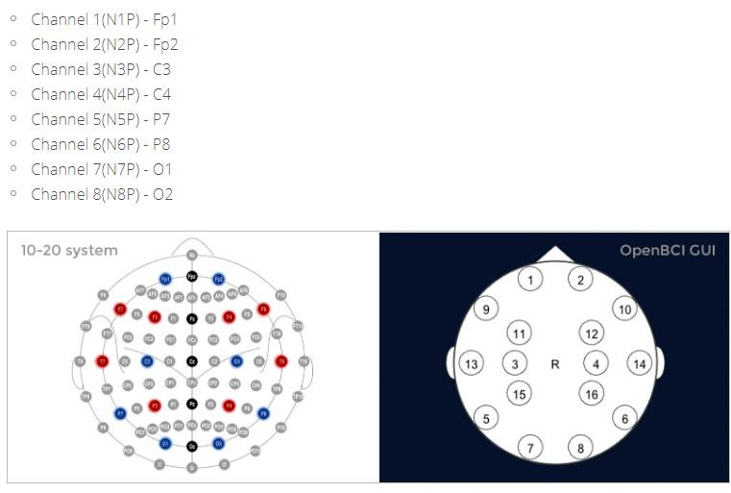The number of user subjects has to be taken into account. The more the user subjects the more realistic accuracy results.
2. The number of channels (electrodes) used for signal detection and processing. The higher the signal detection and accuracy are the more the transmitted channels, but the less comfort the user has to add a lot of electrodes to his scalp.
3. BCI systems that require calibrating its parameters such as classifier on each subject user using offline training should yield a better accuracy than a generic system. This is because the program will be tailored to the brain signals of each user and will also give the user a chance to have a good experience of using the system before the online test. The parameters will not be changed according to each user's brain signals in a standardized framework (like the existing method) so it would be a challenge to achieve a good accuracy.
4. The number of tested characters in the online test affects the results accuracy as the greater number of the tested characters reflects realistic accuracy results, but at the same time user subjects gets fatigue and lose concentration in long testing sessions so the number of tested characters may affect the accuracy results in both directions.